Name: Rimsha Sana Rasheed
Section: D1
ID: 151
Submitted to: Sir.Talha Khalid

OS LAB TASK-II
Operating System
Linux user management and process control (Kali Linux)

QNO1. Create a new user
Objective: To create a new user account in Linux.
Command Used
sudo adduser student1
Description
In this task I created a new user named student1 on Kali Linux using the adduser command with sudo, since creating accounts needs administrative rights. The system asked me to set a password and then to enter extra details: full name (rimsha sana rasheed), room number, work phone, home phone and other. I confirmed the information with y and the account was created.
To check the result, I ran the same command again. The system replied "The user student1 already exists", which confirms that the account was created successfully.
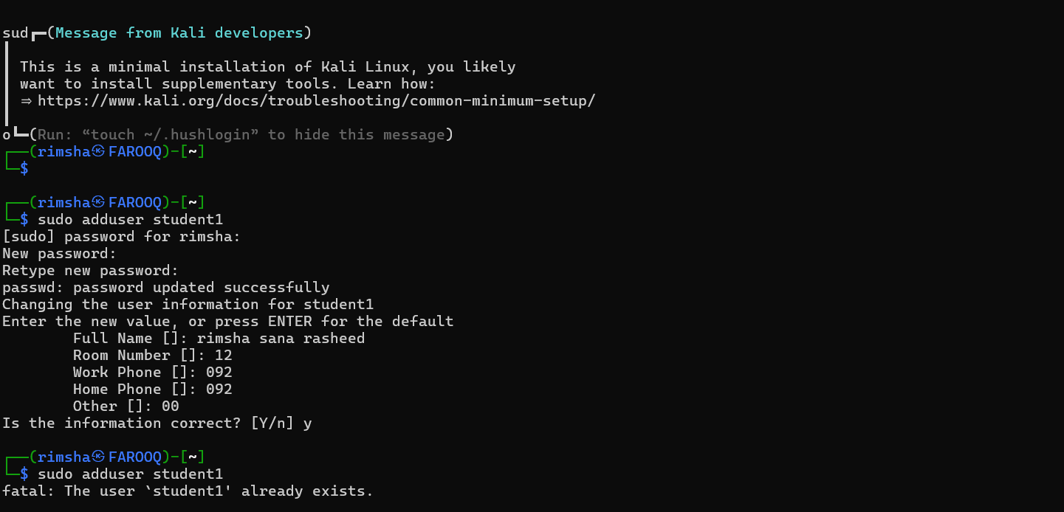
Figure 1: Creating the user student1 with adduser

QNO2. Modify a user
Objective: To modify the information of an existing user and verify the changes.
Step 1: Modify the user
sudo usermod -c "Practice student" student1
The usermod command changes the settings of an existing account. The -c option updates the comment (GECOS or full-name) field of the user. The command is run with sudo because only an administrator can modify other accounts.
While working on this task I first typed an invalid option (-1, the number one, instead of -l, the letter L). usermod rejected it and printed its usage screen, which lists all the available options, such as -c for the comment, -d for the home directory, -l for the login name and -L to lock the account.
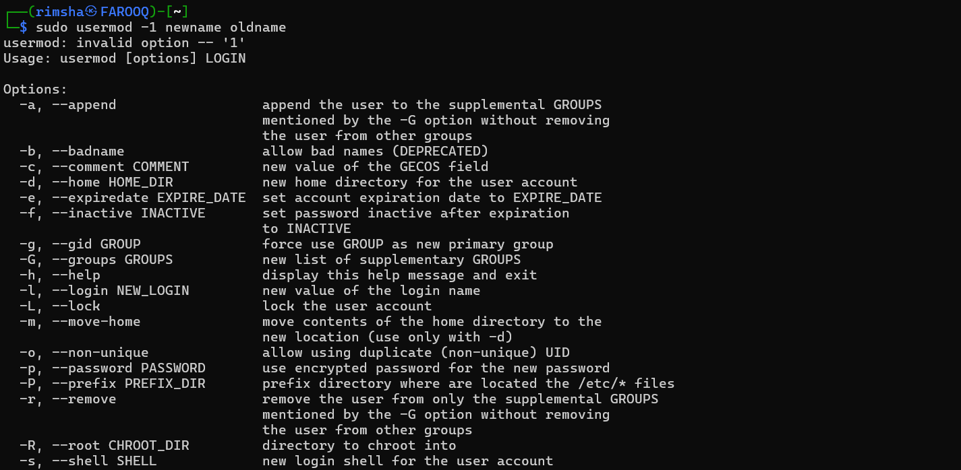
Figure 2: usermod options list shown after an invalid option
ADD SCREENSHOT: run sudo usermod -c "Practice student" student1 from your admin account (rimsha) and take a screenshot of it here.
Step 2: Verify the changes
getent passwd student1
The getent passwd command prints the account entry of student1. The output shows the user name, user ID, group ID, the updated comment, the home directory and the default shell, so the change can be checked.
ADD SCREENSHOT: run getent passwd student1 and paste the screenshot here. The comment field should show your new text.

QNO3. Open Linux Task Manager
Objective: To view running processes and system resource usage in Linux.
Command Used
top
Description
Before this step I reset the password of student1 using sudo passwd student1, which updated it successfully.
I then ran the top command, which is the Linux equivalent of Task Manager. It shows a live view of the system: how long it has been up, the load average, the number of tasks, CPU usage, memory and swap usage, and a table of processes with their PID, user, priority, memory use, CPU use and command name.
In my output there were 18 tasks in total (1 running and 17 sleeping, none stopped or zombie). The CPU was 100% idle, and the memory showed about 3807 MiB total with 438.9 MiB used. The first process was systemd with PID 1, owned by root. Pressing the q key exits top and returns to the terminal.
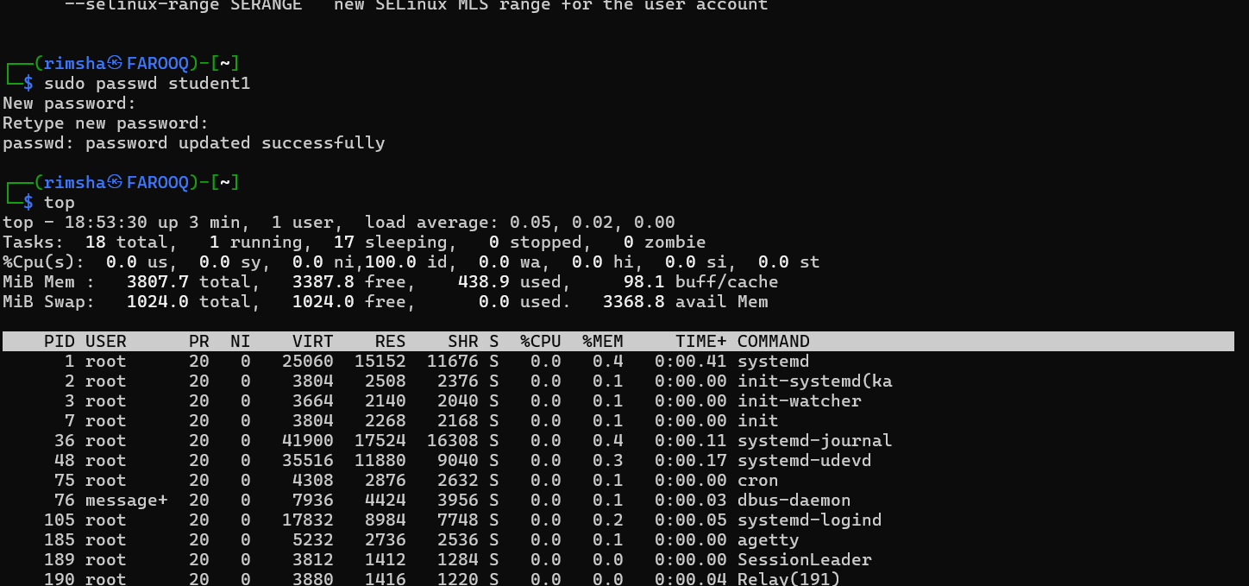
Figure 3: Output of the top command

QNO4. Kill any process
Objective: To identify and terminate a process in Linux.
Step 1: List and find processes
ps aux
pgrep -a firefox
The ps aux command lists every running process with its owner, PID, CPU and memory use, start time and command. Each process has a unique Process ID (PID), which is needed to stop it. I also used pgrep -a firefox to search for a process by name. It printed nothing, because Firefox was not running on this system.
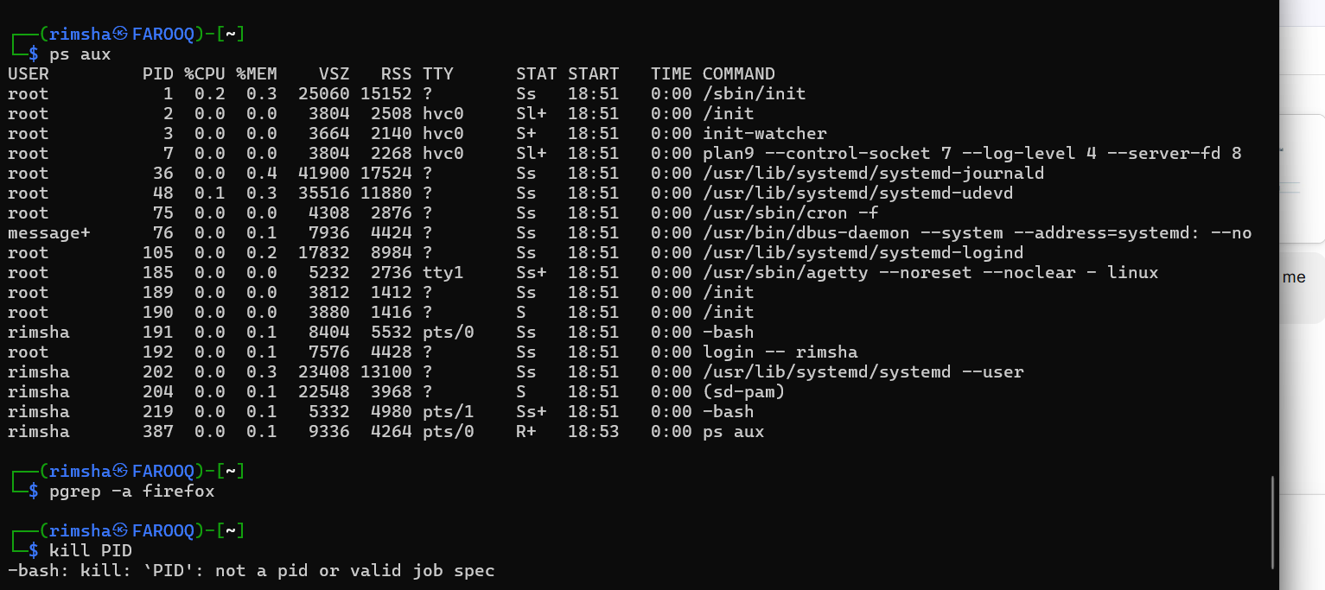
Figure 4: Listing processes with ps aux and trying kill without a real PID
Step 2: Terminate a process
kill PID
The kill command sends a termination signal to a process, and it must be followed by a real PID number. When I typed the word PID literally, bash replied "not a pid or valid job spec", which shows that kill needs an actual number such as one taken from ps aux.
ADD SCREENSHOT: run sleep 300 & (it prints a PID), then ps -p <that PID>, then kill <that PID>. Take one screenshot that shows all three, and use the real PID number in the commands.

